BAM APRIL 2024 PROJECT ACTIVITY REPORT.

On the 15th of April, Bam animal clinics started a week-long donkey welfare clinics campaign in the District of Bukwo in Eastern Uganda. The main activities preceded a mobilization program for about 3 days to have several
Donkey owners attend our clinics in the various sub counties in District.

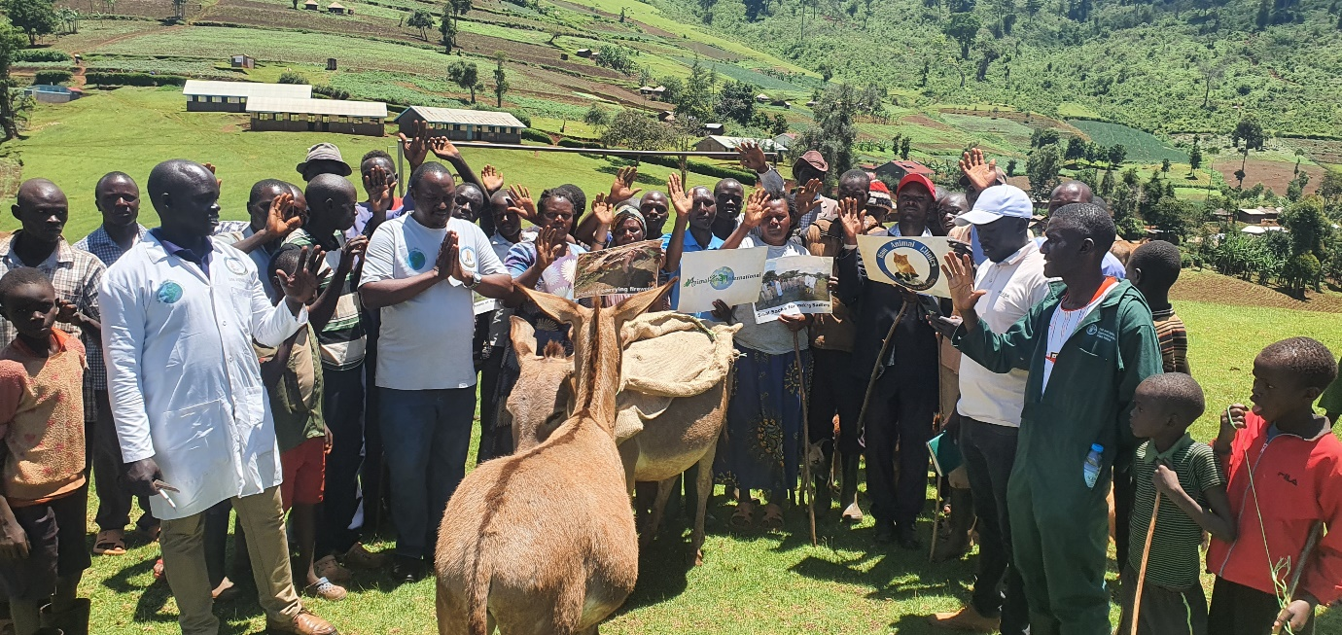

High in the hills of Bukwo, staffs of Bam animal clinics mobilize communities to attend the Donkey welfare training in accordance with the scheduled days. Because of the hills here, a mobilizer uses a megaphone to send the message and this gets far than home to home approach.
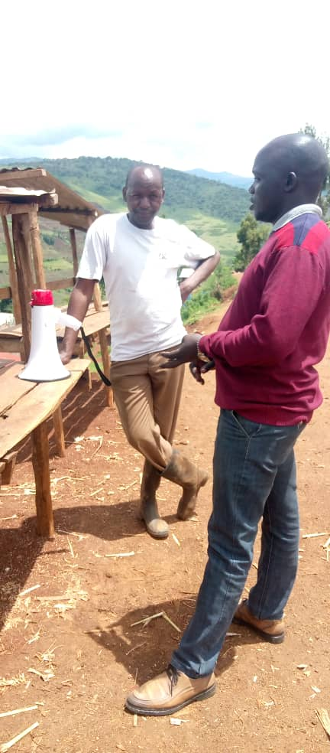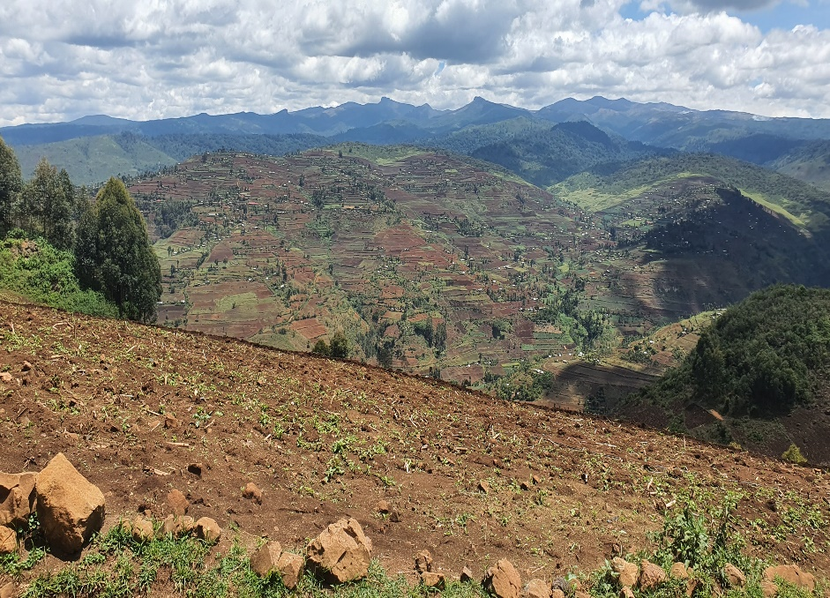

Animal-Kind International supports Bam to be able to reach out to several Districts in Eastern Uganda to train Donkey keepers on Humane handling, Use of proper saddles, proper feeding, treatment and care among the many other welfare aspects of Donkeys.

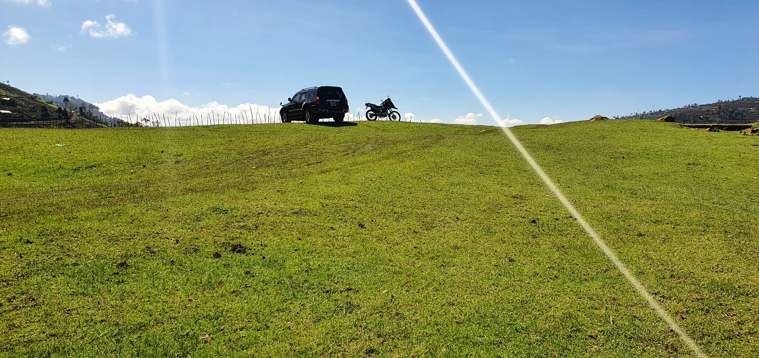
If you took a look carefully at the hooves of this donkey, you will appreciate our quest to intervene in the welfare issues of donkeys here.
Many donkeys live with these extended appendages while working even harder for their masters but have nothing to do to help them. Our intervention is proving them wrong and we hope communities here will change for the better after our long-term interventions through demonstrations

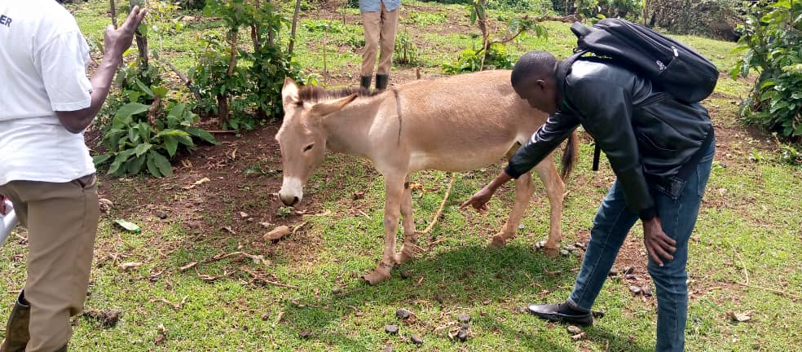

Bam will support hundreds of donkeys with these anomalies to regain their once normal physical body conditions.

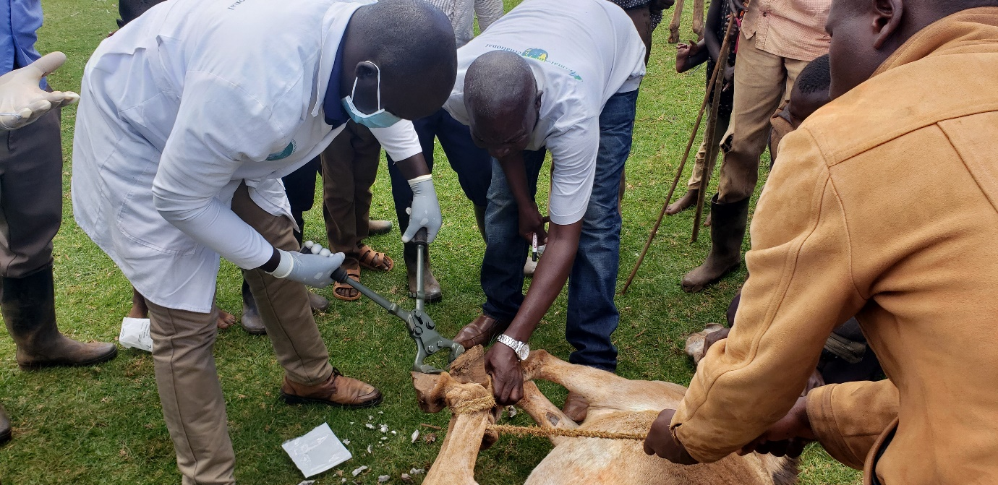

Training session on donkey welfare for pupils of Kortek primary school in Kortek sub-county Bukwo District. This is in line with our donkey welfare program, in most areas we train, we reach out to children either in schools or in communities to involve them in knowledge acquisition as the children are the future adults who if not trained, they will be the masters of cruelty to the animals.
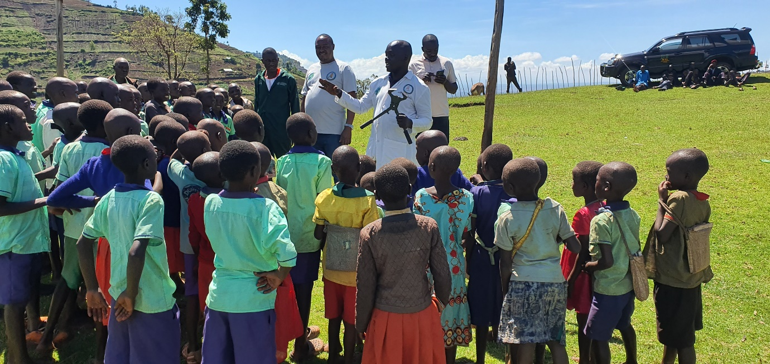

A team of 30 students from Amanang secondary school Bukwo were selected as pilot group that will participate in various Donkey Welfare Weaving' workshops with partners from Bangor Co Down UK in the coming months. Having read about our work for the donkeys here, the team at Finnegan Tools will support a training program at one selected secondary school and provide a few utilities for making Carts for donkeys to reduce on the burden of over loading donkeys. The cart component is actually lacking in this region, even in areas with less terrains where carts would serve more in currying even heavier loads. Once carts are used and are designed in a professional way, carts can carry double the usual weight and the donkey is safe from over burdening.
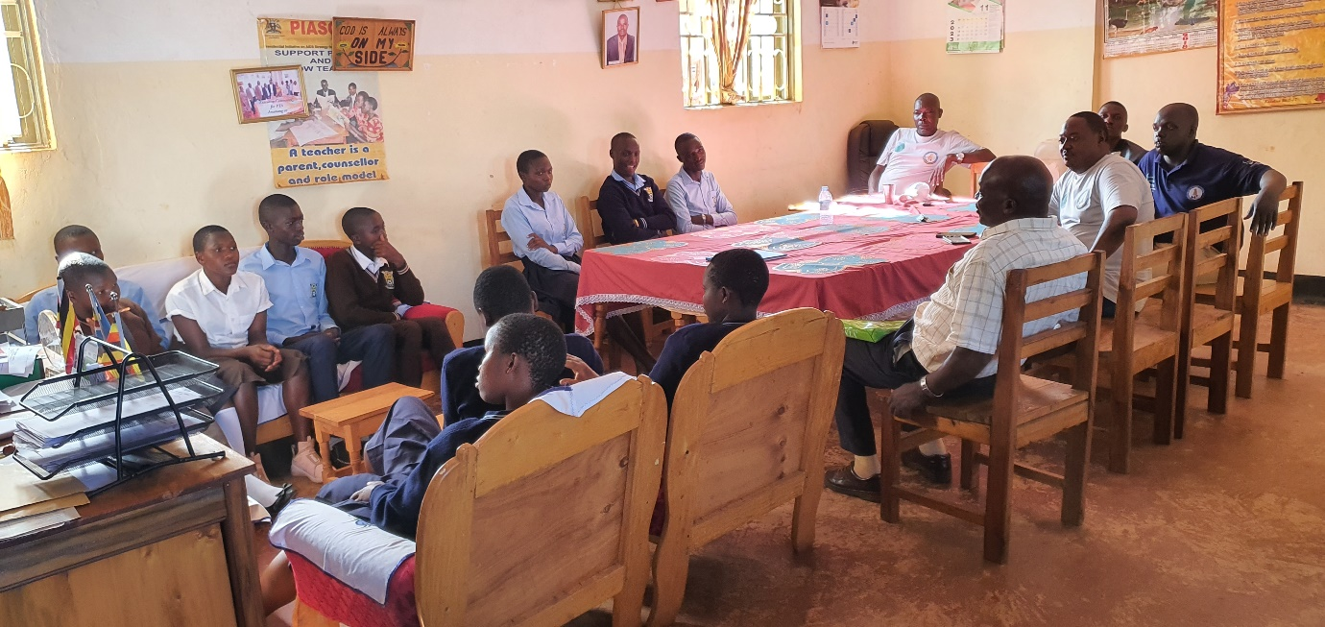

Bam Animal Clinics held several donkey welfare clinics in the Sub-counties of Kortek and Senendet. The team made a curtsey visit at the Subcounty head quarters and thereafter, proceeded to Kortec primary school for several activities.
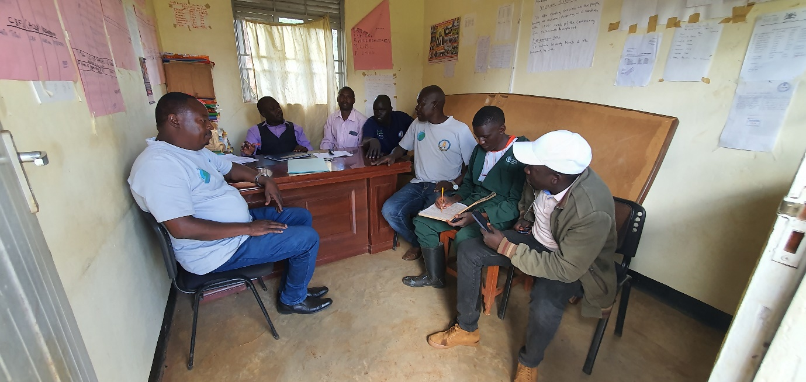

Many thanks to Animal-Kind International for supporting our work, over 220 donkeys were attended to with several community donkey owners attending humane management trainings.
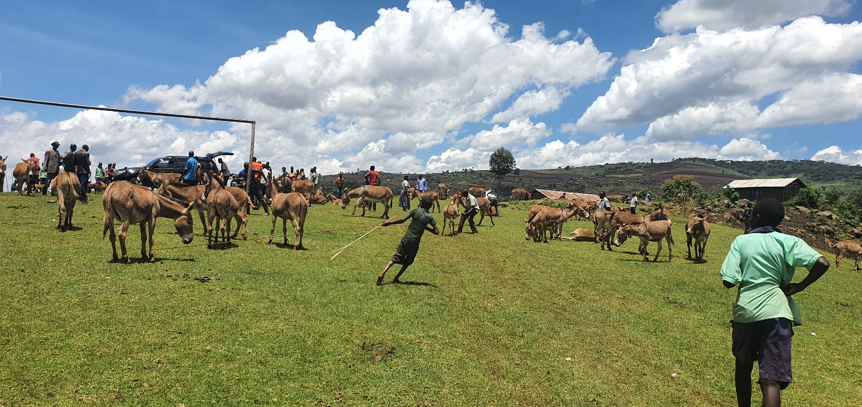

Cases of abuse are everywhere as in these sub counties people have not learnt how to make and use our sisal saddles. Most donkeys here have injuries as a result of poor harnesses and saddles.
Donkey keepers attend a saddle making session at Kortek primary school. They promise to adapt the use of these Saddles to protect their donkeys from injuries while currying produces
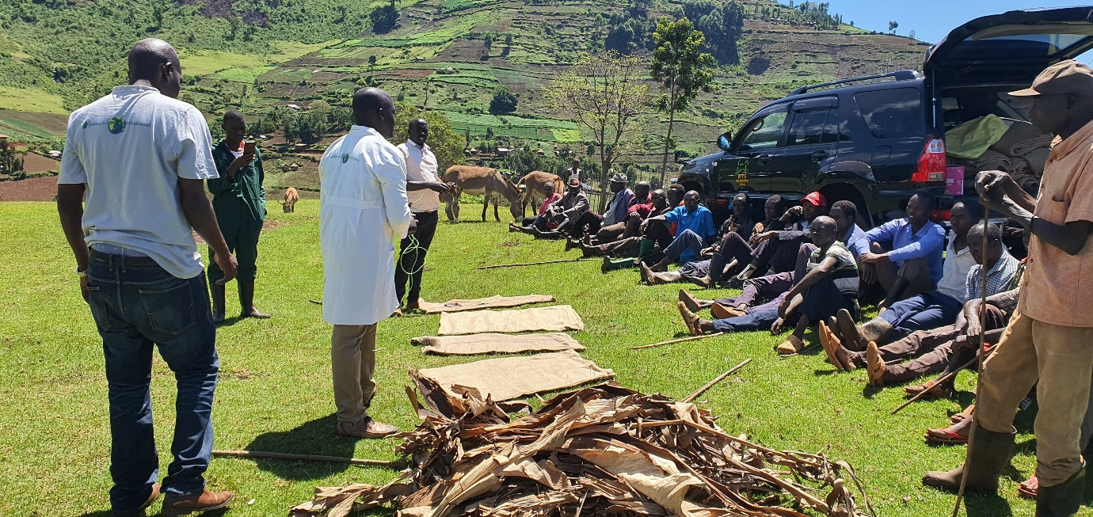
Because of the nature of the topography, its hard to curry produces from the gardens and quite often Donkeys are used to do most of this work. In some cases when the costs of hiring a donkey are high, then human labour is used, problem is even young kids at school going ages are used and many have dropped out of schools because of the pet jobs, some have chronic conditions arising from this practice.
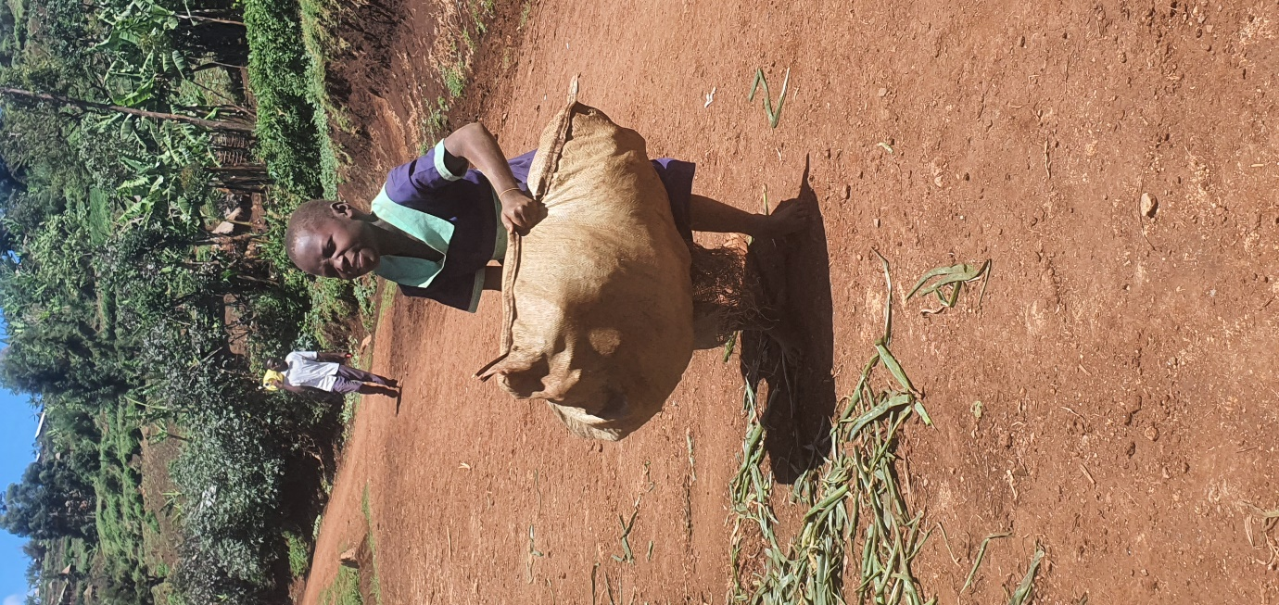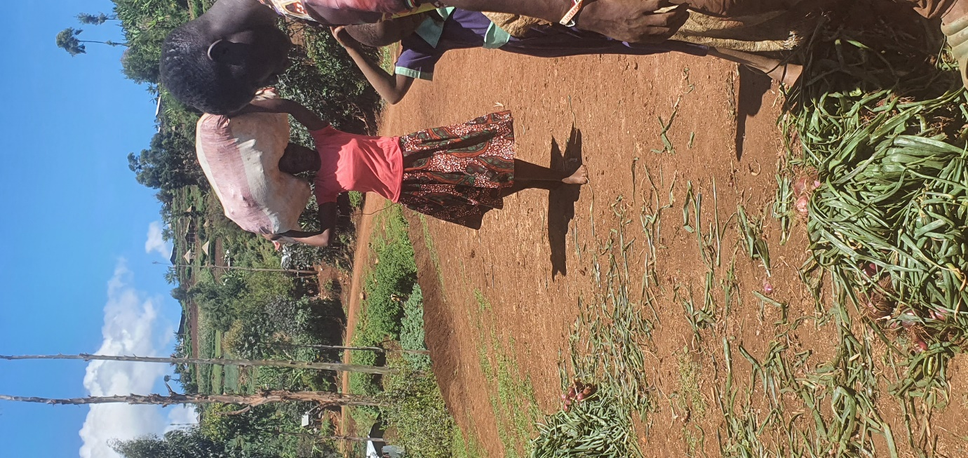

A woman stands a top of a hill next to her Donkey at Cortek primary school waiting for Bam Animal Clinics team arrival. Majority of people who use donkeys on day-to-day basis are the women and this is the reason we encourage men to allow their wives come and attend to our trainings. We were to conduct a donkey welfare activity here. Over 220 Donkeys were attended to; treated, de-wormed and trimmed of their hooves among other cares.
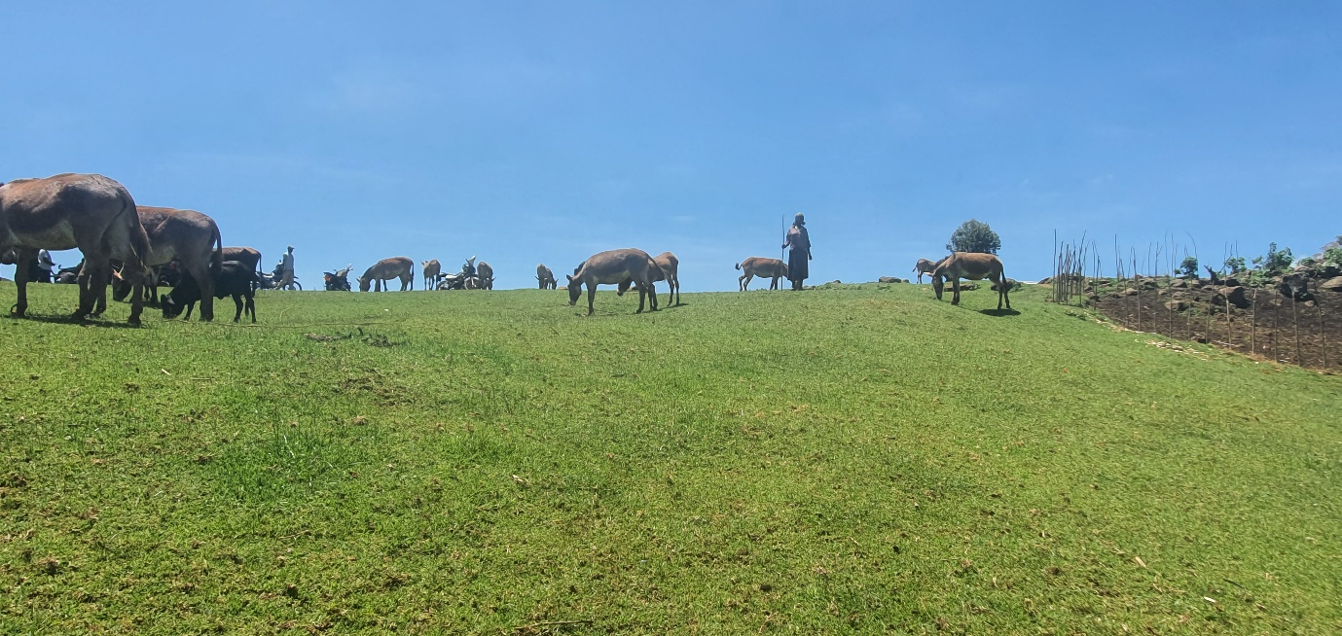
This is Kortek p/s football pitch that looked amazing by its nature! Besides several donkeys seen arriving, where the owners will undergo welfare training and the donkeys will receive treatments and other managements as much as possible by Bam Animal Clinics.
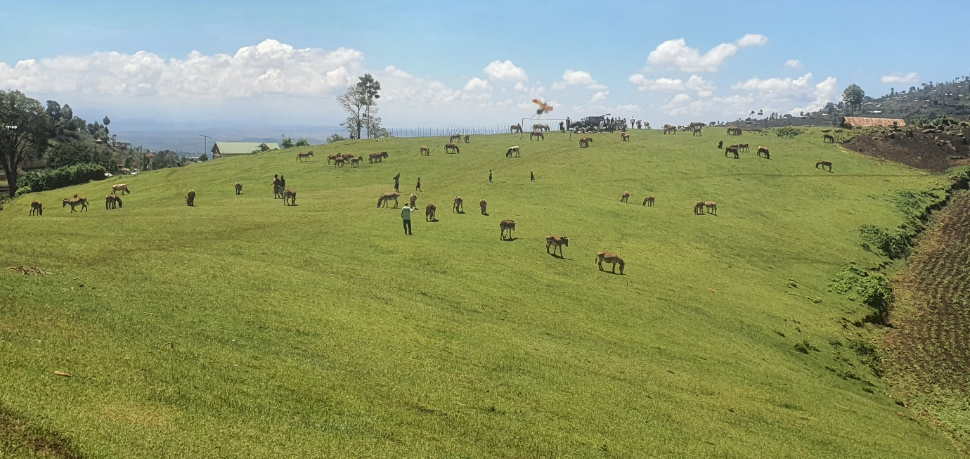

Bam Animal Clinics works to improve the welfare of all animals. The Donkey community is renowned for keeping many dogs. We have a component of vaccination, Spay and Neuter, we attended to over 40 dogs brought on site, we treated against internal and external parasites and given resources, we promised them spay and neuter and rabies vaccinations among other supports.
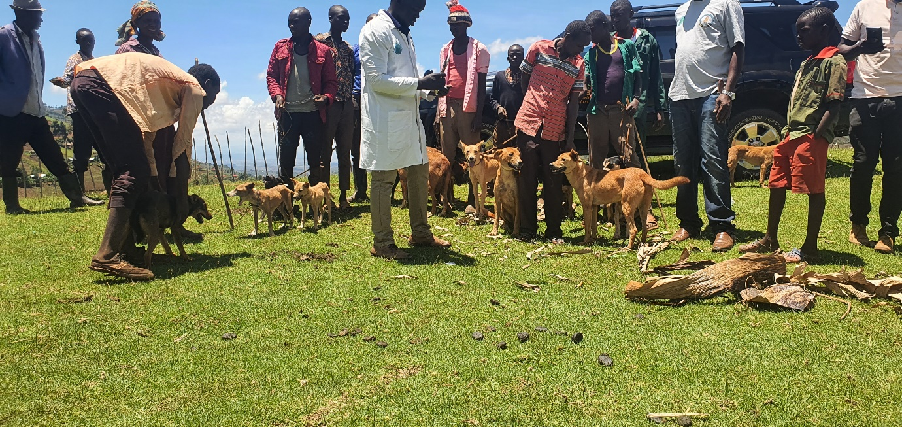

Asked if there were any vaccinations against rabies going on in the area, the answer was NO! Dogs are the principal reservoir of rabies virus in developing countries and are responsible for 99% of human infections. There is need to devise practical rabies prevention strategies for dogs, working donkeys and the people inhabiting these especially remote areas as they are at a high risk of rabies exposure.
The vast area of this region is covered by the mountain Elgon and part of it is protected conservation area called Mountain Elgon National Park (MENP) where hyenas, jackals, feral dogs, wild cats, bats and monkeys are common. Dogs are used for hunting and for guarding homesteads. Dogs fight off, and act as deterrents for hyena, jackal, feral dog and wild cat attacks on people and other livestock such as cattle, goats, pigs and chicken. However,
Cruelty is not exclusively to donkeys in the donkey communities in Eastern Uganda, but also for Dogs and other animals equally.
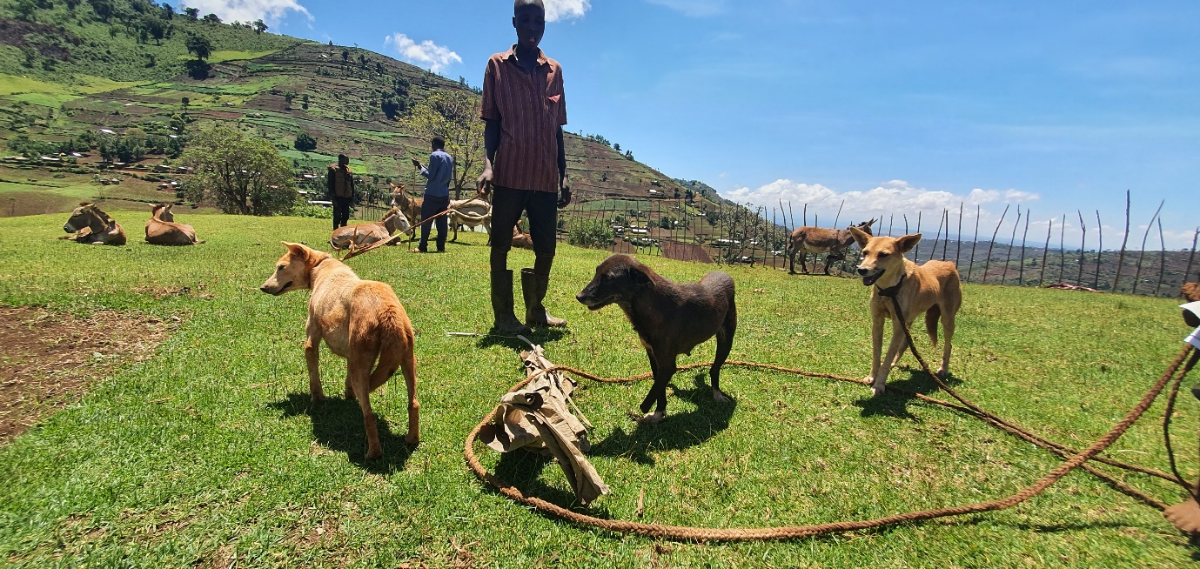
This dog was a victim of a machete wielding thug who invaded Mr Kiptoo's home at a one night with an intention to still his Donkeys. The region has suffered immensely from donkey thefty for trade of their skins, a hot business for the Chines here unfortunately! So, on the fateful night, the thugs hacked a number of his dogs, he lost about three and this one survived but lost one of her fore-limb. Fortunately, because of the chaos, he saved the donkeys as he was joined by the neighbours who helped to repulse the attackers.
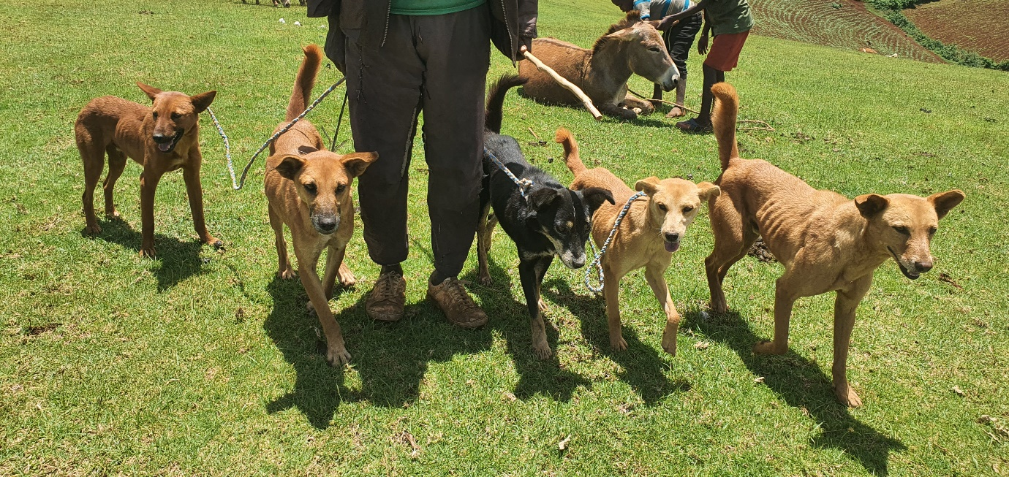

Kapnandi road to Senedet subcounty another subcounty with many donkeys in Bukwo. We trained Donkey owners, met school kids and trained them on humane donkey welfare, we also treated their donkeys free from any charges and distributed saddles curtsey of Animal-Kind International support. Donkeys were treated for various ailments including internal worms, ecto-parasites and others.
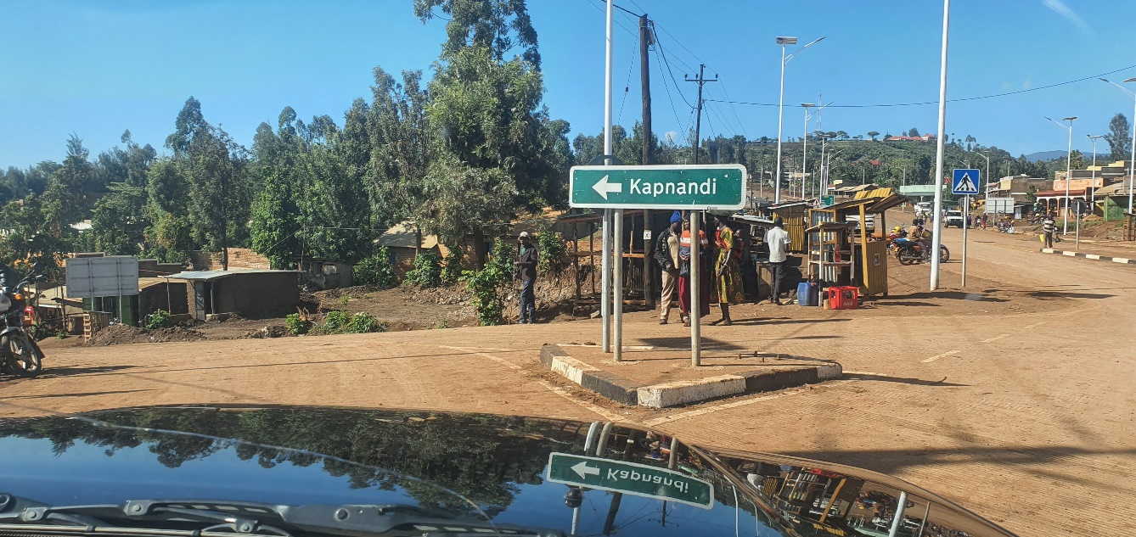
Many primary school kids converged under the guidance of their teachers to attend to Bama team. They asked several questions and had them answered well by our team.
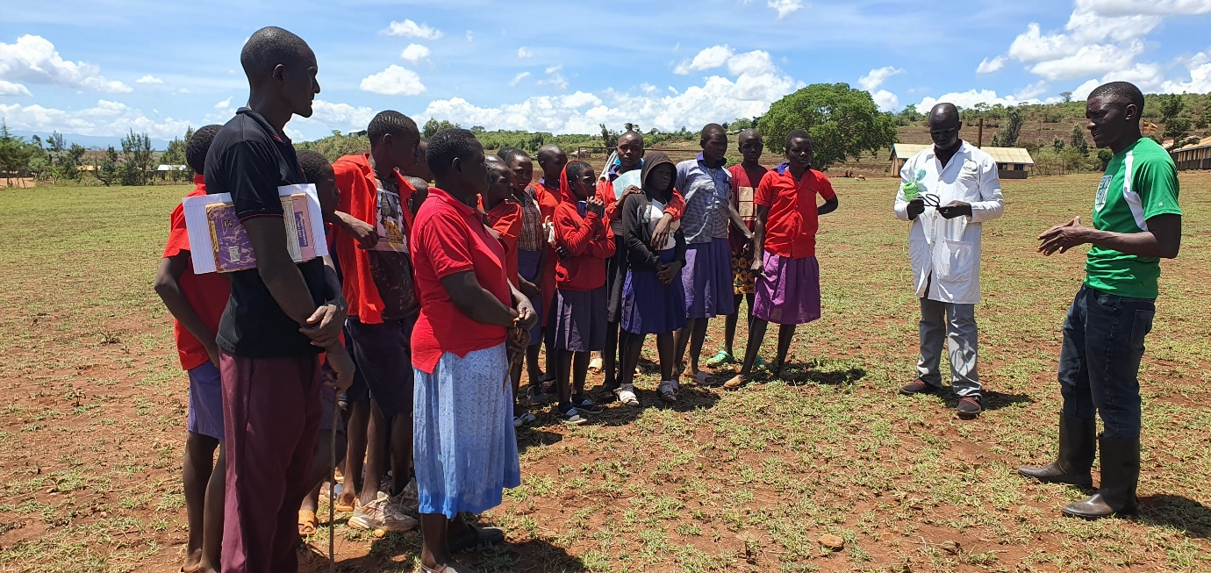
We challenged the community to demonstrate a better handling skill and a one Martine was able to show how he was handling his donkey. He tried though still had to be trained more but there was something to learn from the community.
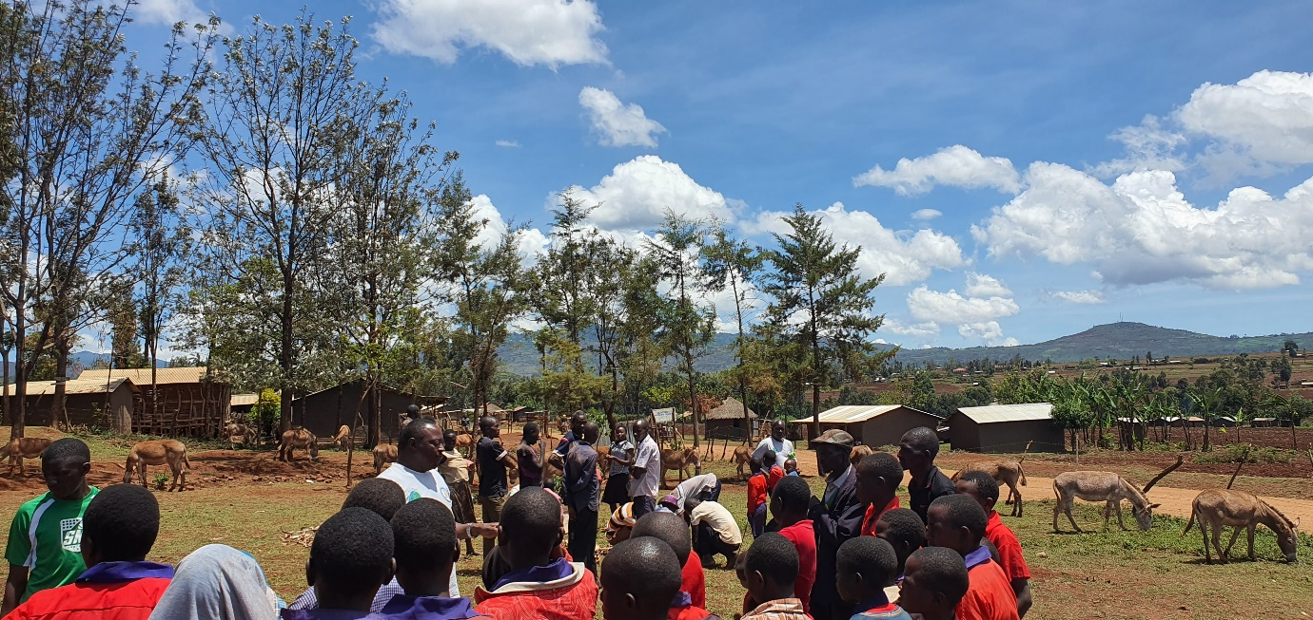
A participatory approach was adopted as community members fully participated in the saddle making process, they also were very participative in the welfare discussions and were happy to have us on the ground training them of how they would handle their donkeys. Majority had never had any vets coming to train them about donkey welfare. After the training, we reached out to the donkeys and helped address issues as they were presented including worm controls etc.
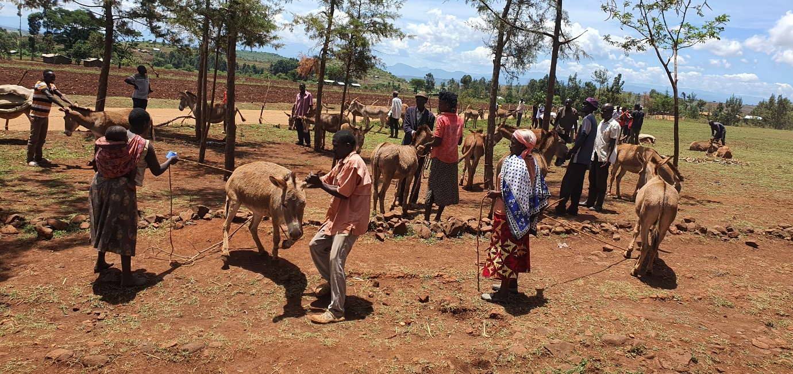
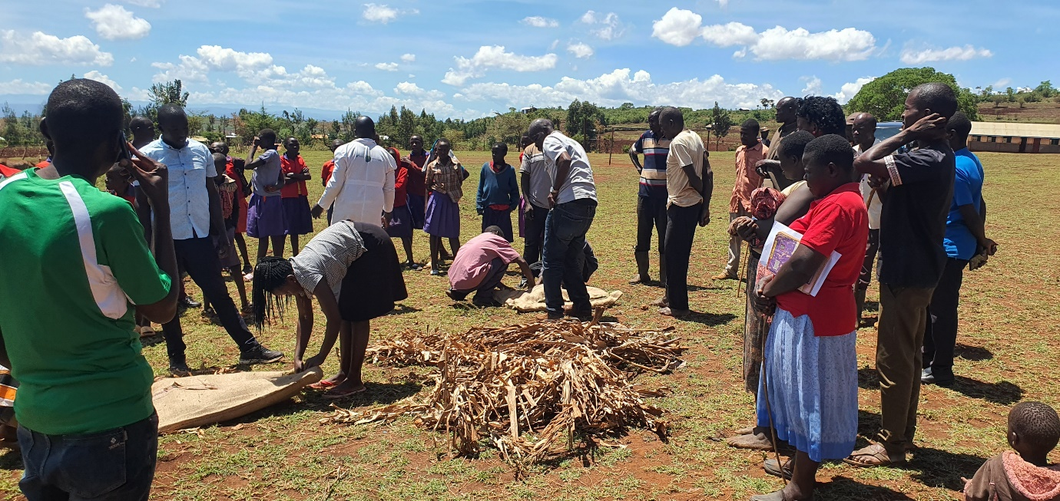
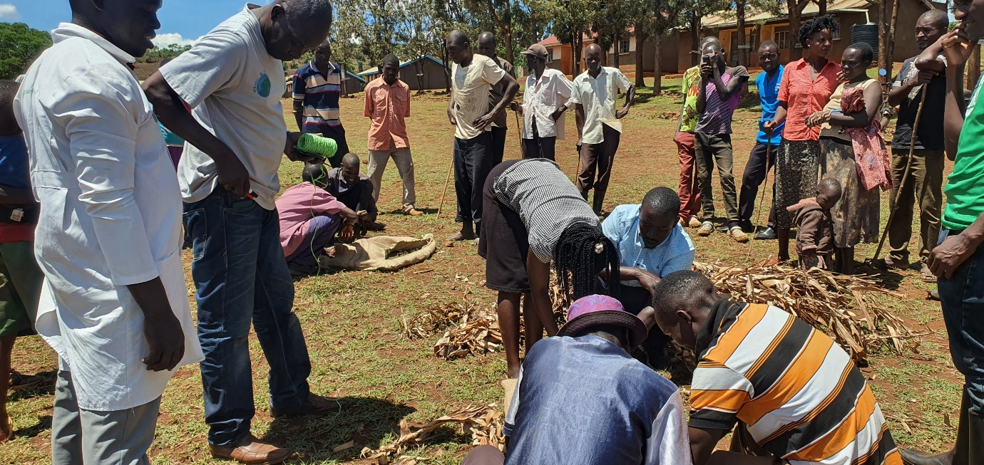
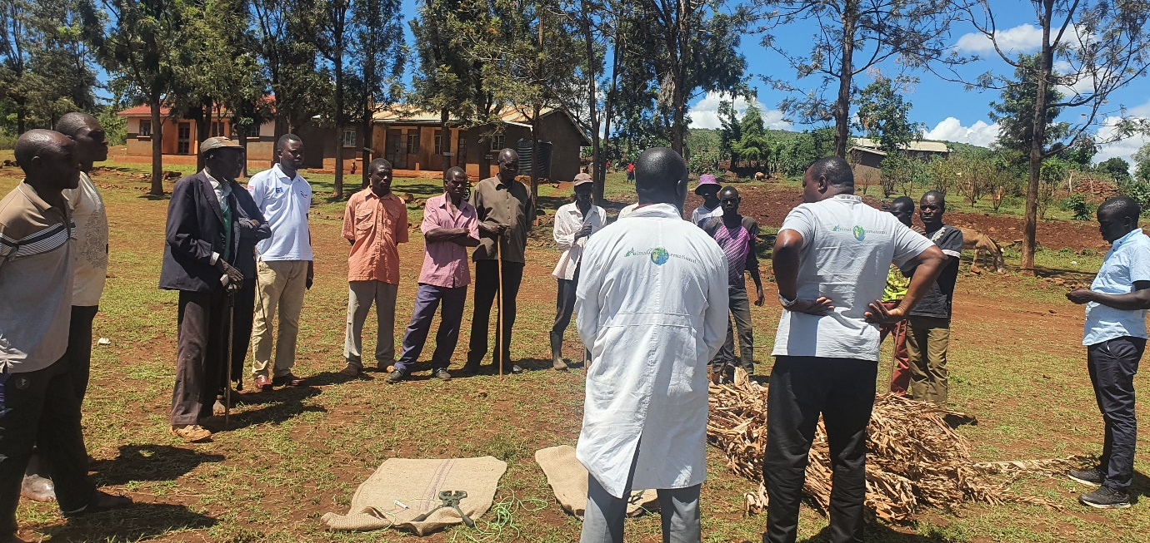
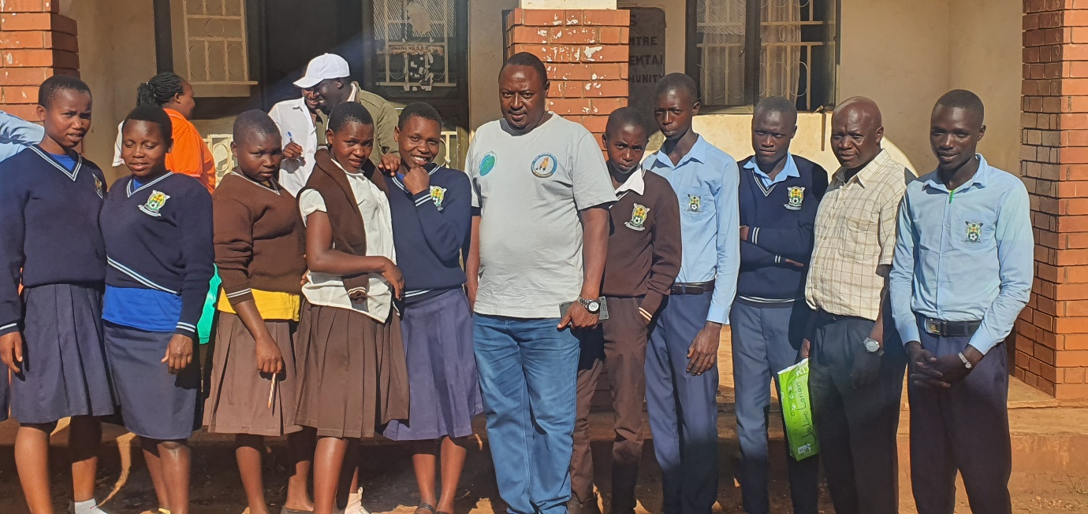
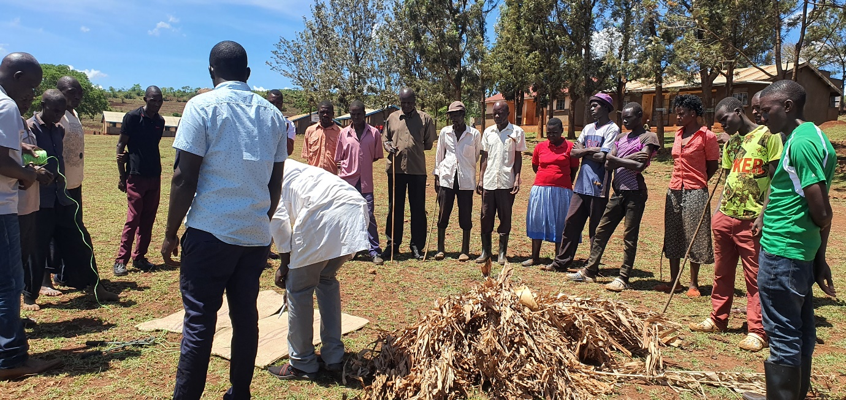
We have several pictorial to share about the various activities during our entire visit.
Thanks
David Balondemu
Director Bam animal clinics

